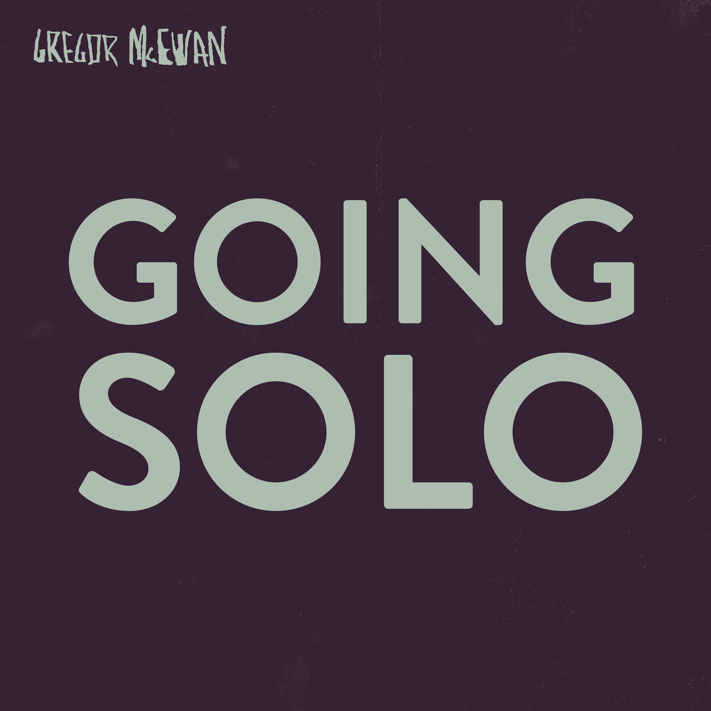  
  
GREGOR McEWAN - GOING SOLO (RD: 01/09/23)  
(<< Rewind Retrack Recordings / recordJet)  
  
a press release by Linus Volkmann

**He is one of the best songwriters in this country. Gregor McEwan can make you bop along and howl at the same time. With "Going Solo" he now releases his key work, his "White Album". Multifaceted, nuanced and never without those tender melodies that you suspect you'll never get rid of them now. Why should you?**

**The basics first: Gregor McEwan no longer parks his guitars, effects units and everything else he uses to create his rough and vulnerable sound in Berlin. He has exchanged the hyped Wall City Moloch for something more idyllic. East Frisia, or so the rumour goes.   
"Going Solo" is his fifth album and gets to the heart of his work as well as to a new level. A record that resonates, a record that above all shows that McEwan has not only further adjusted his songwriting, but also his storytelling.**

**In the song "(To You) CEO, Bitch", for example, our man with the jokey actor's name simply nails the entire zeitgeist in just a few syllables: overall, it's about the sad streaming reality for artists that doesn't want to allow any nuances or creative detours - and in the concrete sense, of course, about the Spotify founder who now shamelessly makes his investment in weapons. This tune makes all that sensible just after a few seconds - and then formulates it with a great taste for aesthetics and lyrics. Please wake me up if a guitar song should ever be more pointed and rousing than this one! This is followed by "Anthem For The Year 2020", based on a track by the Australian band Silverchair, whoever remembers them gets a bee sticker in their diary. The song definitely represents a lockdown anthem that manages to pack all the ambivalence of the first pandemic year into words and chords. It's about taking a time out from the constant hustle and the simultaneous threat to one's existence. McEwan also succeeds here in condensing without flattening intermediate tones. On the contrary, they are simply sung along.**

**The song "My Little Girl" is incredibly warm. Exciting steel-string naturalism, currently pushed by FINNEAS, for example, who produces the records of his little sister Billie Eilish in a similar way. Lyrically, "My Little Girl" is reminiscent of one of Gregor McEwan's most emphatic crowd-pleasers "On Her Radar", with his unique voice he now romanticises the precariat here. It may not be a socio-critical text, but with this in mind, the author tells a big love story, "no certainties, no stable income, too small to succeed, too big to be gone". All the insignia of a successful adult life seem to be missing, the Free Democratic Party is about to cry, but the emotions shine bright. This is an unforgettable melody of longing, this is minnesong 3000!**

**The latest release from "Going Solo" is "Halo: Reach". Another love song that can refer to ego-shooter-games like Quake and the 80s cult figure Pat Benatar in the same breath. But you don't have to be able to hear that, because a good song doesn't need an answer book, in the best case, like this one, it is the answer itself. So it's better to let the music do its thing...**

McEwan's now fifth record closes with "The End.", a tender but fearless tune that outcalls all the clowns of the present. The song is about church dudes, climate change deniers, lobbyists, conspiracy theorists and more. Highly emotional and casually performed by one of the last great singer-songwriters before the apocalypse and featuring the line "I'm on a mission cause no algorithm can write me a sad sad sad song". Okay, lighter out, heat up the pen, this record is built on quotes that should all be tattooed on your forearm. It's best to paint over the birth dates of your own brood ("Sunkist-Chantal *2015", "Malte-Kohlrabi *2020", or something like that). It immediately looks better... Don't thank me, thank Gregor McEwan!  
"Going Solo" is a collection of glittering pop gems, this is the Gregor McEwan Masterclass! Music for all the shallows out there and in: dipping, crying, bobbing, sinking. Enjoy!

Tracklisting  
(TO YOU) CEO, BITCH!  
ANTHEM FOR THE YEAR 2020  
TALKING…  
UPSIDE DOWN  
60 BPM  
1234567  
HALO: REACH  
BEING AND BECOMING  
MY LITTLE GIRL  
WINDOWS DOWN, VOLUME UP  
THE END.

ALL SONGS WRITTEN & COMPOSED BY GREGOR McEWAN

(FREIBANK MUSIC PUBLISHING)

PRODUCED & MIXED BY GREGOR McEWAN & THIES NEU

RECORDED & MASTERED BY THIES NEU AT TONBRAUEREI, BERLIN  
  
SUPPORTED BY NEUSTART KULTUR, GVL & DIE BEAUFTRAGTE DER BUNDESREGIERUNG FÜR KULTUR UND MEDIEN

ARTWORK DESIGN BY GREGOR McEWAN

LOGO DESIGN BY OLGAUWAGA